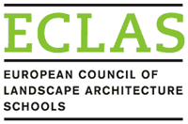
ECLAS AWARDS SCHEME NOMINATION FORM
Please complete the form and send it, together with the supporting material (<8MB), to ECLAS Secretary General - Gabriela Maksymiuk by e-mail to: gabriela_maksymiuk@sggw.pl to reach her by 30 April 2020
The supporting material must include a statement by the nominating institution clearly outlining why the nominee deserves the award. This is especially important and its evaluation forms a major part of the judging process.

Category of award (tick the relevant category) | Lifetime achievement award  Outstanding educator award  Outstanding researcher award  Outstanding student award  1st Cycle (Bachelor)  2nd Cycle (Master)  3rd Cycle (Doctoral)
Name of nominee

Institution and department

Nominated by

Institution and department

Signed:
Date

